Australian Decorative & Fine Arts Societies Inc – GOLD COAST SOCIETY

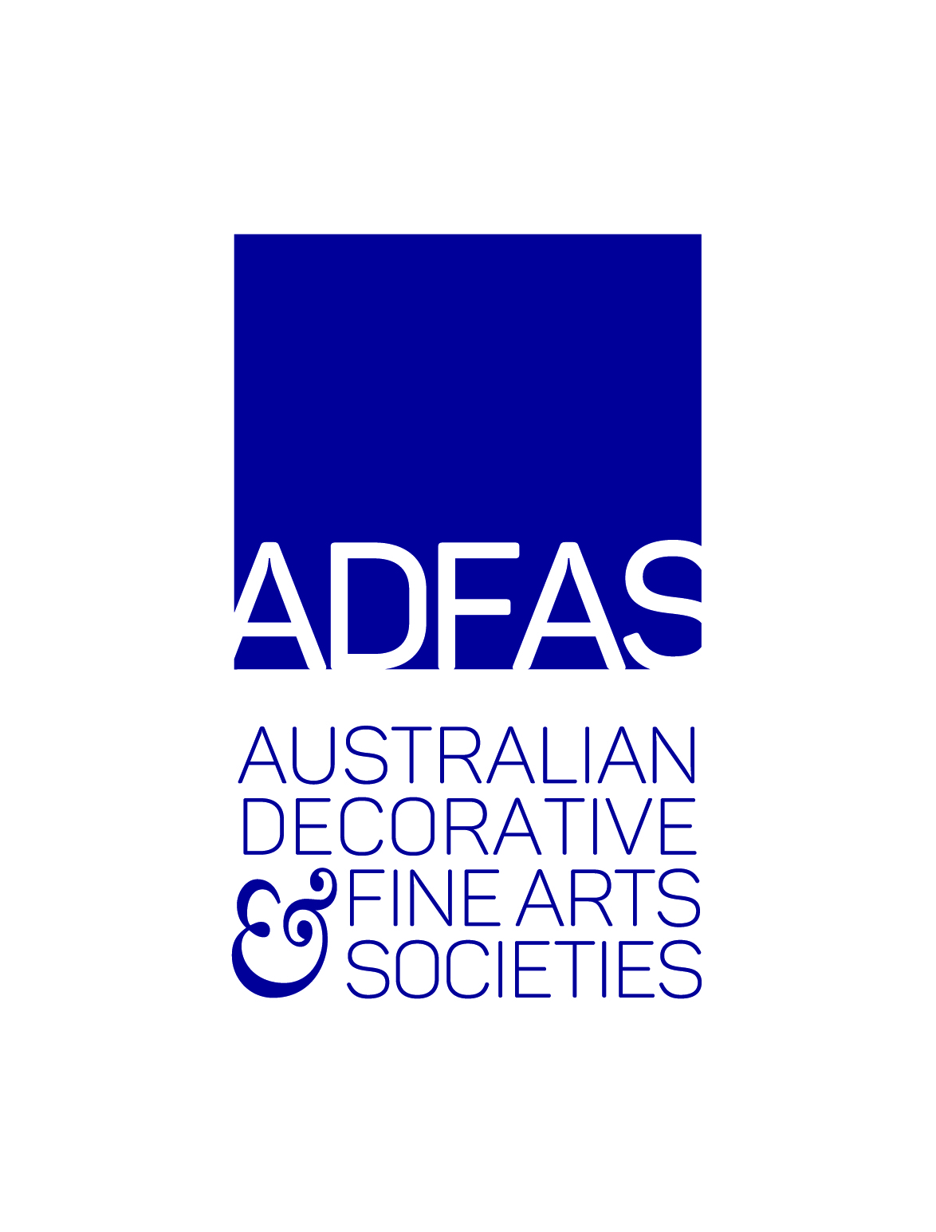
ABN – 77 428 160 468 Group – Associate – Member of The Arts Society

NEW MEMBERSHIP APPLICATION & SUBSCRIPTION 2021

Name 1…………………………………………………Name2…………….………………………………………………………

Address …………………………………………………………………………………………………………………………………..

……………………………………………………………………………………………………. Post Code………………………

Telephone (landline) ……………………………………Mobile …………………………………………………

Email …………………………………………………………………………………………………………………………… (please print clearly)

I hereby apply for 2021 ADFAS Gold Coast Membership and I agree to be bound by the Constitution & Bylaws.

Signature 1 ……………………………….…………… Signature 2 ……………………………………………………. Date………..………………….

Public Liability Insurance of $20,000,000 is held by ADFAS Gold Coast under the Association of ADFAS’s Insurance Policy with TBIB Insurance.
Compliance with the Privacy Act: I consent to have my name and email address (where available) added to the ADFAS database, and for them to be used to provide periodical information to me about ADFAS activities. You may Unsubscribe from these emails at any time by notifying the Membership Secretary at membershipsecretaryadfasgc@gmail.com or at PO Box 7737 GCMC Q 9726.
__________________________________________________________________________________________________________________________________
Your 2021 Membership subscription is now due.
Please complete the following details and amounts:
Membership Subscription
Single $ 175 $ _______

Double (At one address only) $340 $ _______

Arts Society Magazine Subscription
(Payment must be received prior to 20th January, 2021) $ 30 $ _______

Donation to ADFAS Young Arts Projects (Optional) $ _______

Donation to the Patricia Robertson Fund (Optional) $ _______
TOTAL AMOUNT PAYABLE: $ ________

Dear Members, please note that Gold Coast ADFAS membership & any associated membership benefits are not transferable.

Payment Options: a) Cheque made payable to ADFAS Gold Coast Inc.
Return cheque and completed form to
The Treasurer, ADFAS Gold Coast Inc.
PO Box 7737 GCMC Q 9726
Or b) Direct Deposit:
Account Name: ADFAS Gold Coast Inc.
BSB 084 044 Account No 531 127 641
Return payment details and completed form to carolalittle@bigpond.com

Enquiries: Membership Secretary, Cara Gordon caragordon44@gmail.com

OFFICE USE ONLY: Payment type: Chq D.D Cash Amount: $ ______ Date Received: ___________

